|  |  |
| --- | --- |
|  | **2nd Capstone Project Nei Costa**  **Human Activity Recognition Using Smartphones**  **Video of Experiment:**  <https://www.youtube.com/watch?v=XOEN9W05_4A> |

**Dataset Information:**

**Abstract**: Human Activity Recognition database built from the recordings of 30 subjects performing activities of daily living (ADL) while carrying a waist-mounted smartphone with embedded inertial sensors.

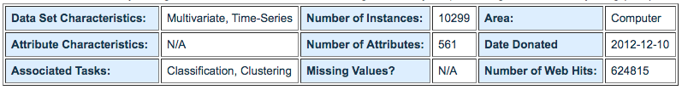

**Source: (http://archive.ics.uci.edu/ml/datasets/Human+Activity+Recognition+Using+Smartphones)**

**Question:**

Is it possible to develop a statistical model that can predict with good accuracy the activity developed by the person based on the information provided by the sensors?

**Pre-analysis of data:**

There are 10,299 records with 561 features each with information about 3-axial linear acceleration and 3-axial angular velocity at a constant rate of 50Hz classified in six different activities, as below:

|  |  |  |  |
| --- | --- | --- | --- |
| **Activity** | **Nº records** | **%** | **Method:**  To evaluate the characteristics of the available information, to compare the accuracy obtained through some classifier models of the sklearn and also through the construction of multi-perceptron neural network using keras. |
| WALKING | 1,722 | 16.72% |
| WALKING UPSTAIRS | 1,544 | 14.99% |
| WALKING DOWNSTAIRS | 1,406 | 13.65% |
| SITTING | 1,777 | 17.25% |
| STANDING | 1,906 | 18.51% |
| LAYING | 1,944 | 18.88% |
| **Total** | **10,299** | **100.00%** |

**Possible Applications:**

Use of electronic equipment in the identification of activities developed in workplaces, evaluation and quantification of activities during sports and other applications.